Zebra Mussels in Oklahoma

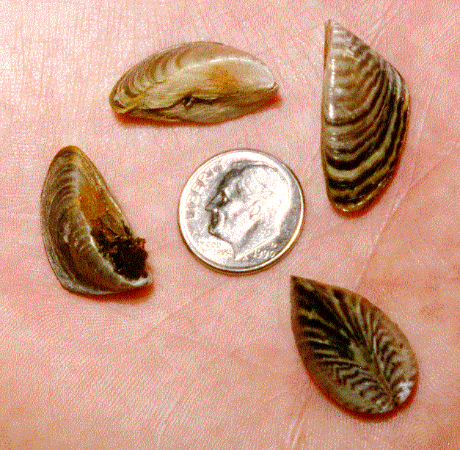
Zebra Mussels are small, thumbnail-size, d-shaped mussels, with a zebra-like pattern of stripes, that are native to the Caspian Sea region of Asia. Zebra Mussels were introduced into the Great Lakes, likely from ballast water from ocean-going vessels, in 1986. From there they have spread throughout the Great Lakes and down the Mississippi River, up the Arkansas River, and into the McClellan-Kerr navigation System. Zebra Mussels were found inside the locks at Robert S. Kerr and Webbers Falls in 1993. They have since been found in Oologah, Lynn Lane, A.B. Jewell, Kaw, Keystone, Chouteau, Sooner, Skiatook, Texoma, and Eufaula Lakes.

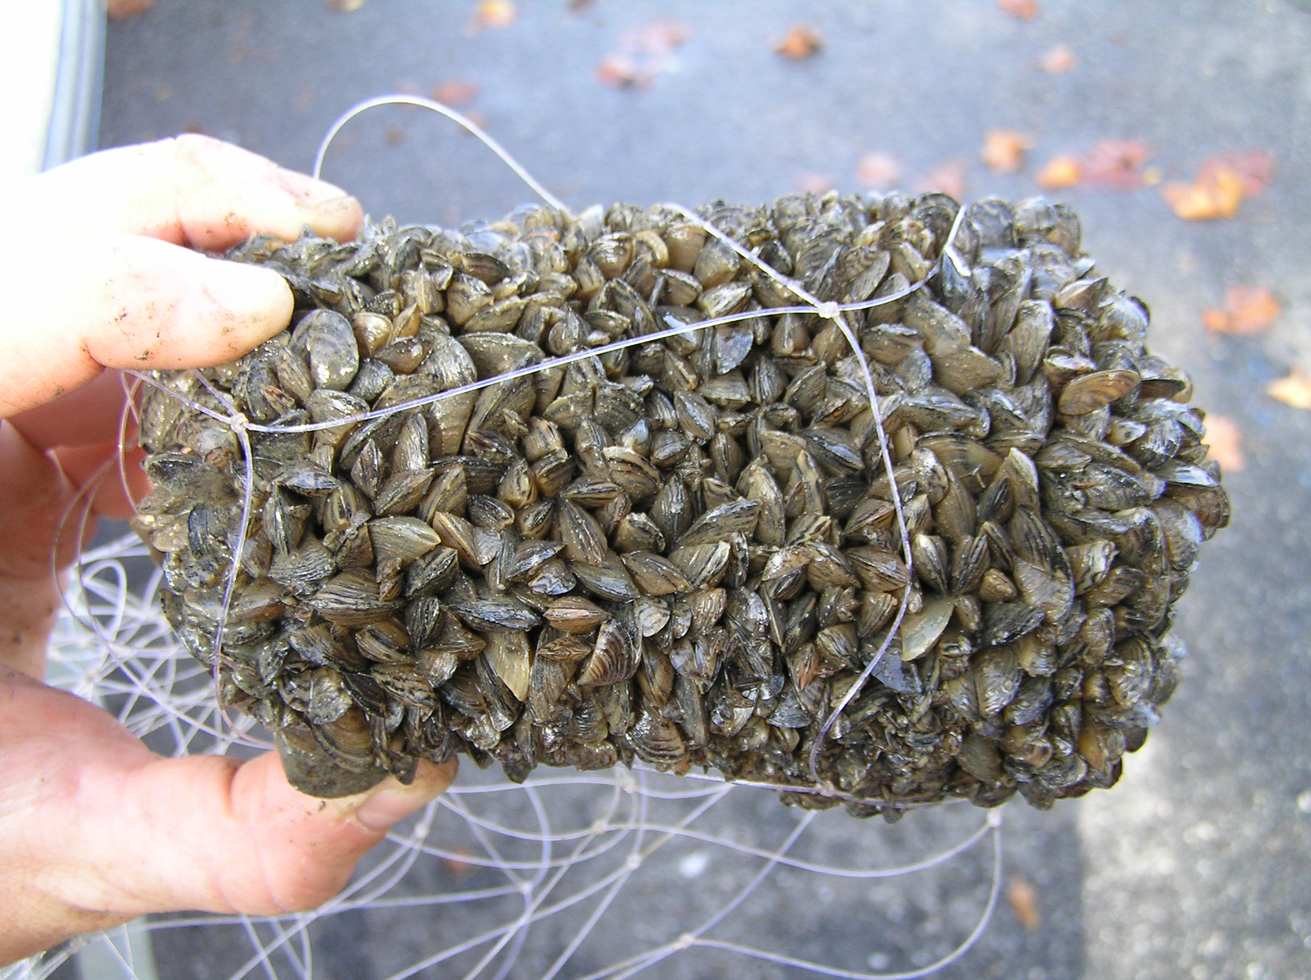
The Zebra Mussel is on of the most economically damaging aquatic organisms to invade the United States. Its destructive power lies in its sheer numbers and its ability to attach itself to solid objects such as water intake pipes, water control systems, boat hulls, propellers, trailers, submerged rocks and vegetation, and even other aquatic organisms. Zebra Mussels can smother native mussels and crayfish by accumulating on the shells. Numbers have been reported in excess of 75,000 per square foot. Zebra Mussels potentially pose a multibillion dollar threat to industrial and public water supplies. The ecological impacts of Zebra Mussels can be severe. Zebra Mussels feed by filtering water and removing nutrients. These nutrients are vital to the growth and survival of all other aquatic organisms.

Zebra Mussels in Oklahoma

Zebra Mussels are small, thumbnail-size, d-shaped mussels, with a zebra-like pattern of stripes, that are native to the Caspian Sea region of Asia. Zebra Mussels were introduced into the Great Lakes, likely from ballast water from ocean-going vessels, in 1986. From there they have spread throughout the Great Lakes and down the Mississippi River, up the Arkansas River, and into the McClellan-Kerr navigation System. Zebra Mussels were found inside the locks at Robert S. Kerr and Webbers Falls in 1993. They have since been found in Oologah, Lynn Lane, A.B. Jewell, Kaw, Keystone, Chouteau, Sooner, Skiatook, Texoma, and Eufaula Lakes.

The Zebra Mussel is on of the most economically damaging aquatic organisms to invade the United States. Its destructive power lies in its sheer numbers and its ability to attach itself to solid objects such as water intake pipes, water control systems, boat hulls, propellers, trailers, submerged rocks and vegetation, and even other aquatic organisms. Zebra Mussels can smother native mussels and crayfish by accumulating on the shells. Numbers have been reported in excess of 75,000 per square foot. Zebra Mussels potentially pose a multibillion dollar threat to industrial and public water supplies. The ecological impacts of Zebra Mussels can be severe. Zebra Mussels feed by filtering water and removing nutrients. These nutrients are vital to the growth and survival of all other aquatic organisms.

Zebra Mussels in Oklahoma

Zebra Mussels are small, thumbnail-size, d-shaped mussels, with a zebra-like pattern of stripes, that are native to the Caspian Sea region of Asia. Zebra Mussels were introduced into the Great Lakes, likely from ballast water from ocean-going vessels, in 1986. From there they have spread throughout the Great Lakes and down the Mississippi River, up the Arkansas River, and into the McClellan-Kerr navigation System. Zebra Mussels were found inside the locks at Robert S. Kerr and Webbers Falls in 1993. They have since been found in Oologah, Lynn Lane, A.B. Jewell, Kaw, Keystone, Chouteau, Sooner, Skiatook, Texoma, and Eufaula Lakes.

The Zebra Mussel is on of the most economically damaging aquatic organisms to invade the United States. Its destructive power lies in its sheer numbers and its ability to attach itself to solid objects such as water intake pipes, water control systems, boat hulls, propellers, trailers, submerged rocks and vegetation, and even other aquatic organisms. Zebra Mussels can smother native mussels and crayfish by accumulating on the shells. Numbers have been reported in excess of 75,000 per square foot. Zebra Mussels potentially pose a multibillion dollar threat to industrial and public water supplies. The ecological impacts of Zebra Mussels can be severe. Zebra Mussels feed by filtering water and removing nutrients. These nutrients are vital to the growth and survival of all other aquatic organisms.

Even though Zebra Mussels likely reached Oklahoma via barge traffic down the Mississippi and up the Arkansas River Navigation System, the threat of spread to inland reservoirs is largely from recreation boaters moving from infested waters to uninfested waters without taking precautions to remove Zebra Mussels from their boat, motor, trailer, and other equipment. The longer a boat remains in Zebra Mussel infested waters, the more apt it is to be fouled by Zebra Mussels. Boats that are moored or docked for more than one day are more likely to be fouled by Zebra Mussels than boats launched and retrieved in a single day. It is vital that each boater takes responsibility to prevent the spread of Zebra Mussels.

Recommended precautions include:
- Run your boat at high speed for 10-15 minutes just prior to leaving the lake. Zebra Mussels may be washed off at speeds exceeding 5 mph and larval Zebra Mussels will be flushed from the cooling system.
- Remove any visible vegetation from boat, motor, trailer, and any equipment in contact with the water.
- Inspect equipment for presence of Zebra Mussels immediately upon leaving the lake. If you find Zebra Mussels attached, wash with hot water (140˚) or air dry for at least 7 days before returning to the water. If equipment feels gritty to the touch, young microscopic Zebra Mussels may be attached. Power sprayers will detach Zebra Mussels.
- Drain all bilge water, live wells, engine water, and bait buckets before leaving the lake. Empty bait buckets on land. Never release live bait in the water.
- Flush engine cooling system, live wells, and bilge with hot water. Water hotter than 110˚ will kill larvae and hotter that 140˚ will kill adults.
- Air dry your boat and other equipment for 7 days before using in uninfested waters.

For additional information about Zebra Mussels go to www.swt.usace.army.mil or www.wildlifedepartment.com. To report findings contact the nearest Corps of Engineers or the Oklahoma Department of Wildlife Conservation office.



Even though Zebra Mussels likely reached Oklahoma via barge traffic down the Mississippi and up the Arkansas River Navigation System, the threat of spread to inland reservoirs is largely from recreation boaters moving from infested waters to uninfested waters without taking precautions to remove Zebra Mussels from their boat, motor, trailer, and other equipment. The longer a boat remains in Zebra Mussel infested waters, the more apt it is to be fouled by Zebra Mussels. Boats that are moored or docked for more than one day are more likely to be fouled by Zebra Mussels than boats launched and retrieved in a single day. It is vital that each boater takes responsibility to prevent the spread of Zebra Mussels.

Recommended precautions include:
- Run your boat at high speed for 10-15 minutes just prior to leaving the lake. Zebra Mussels may be washed off at speeds exceeding 5 mph and larval Zebra Mussels will be flushed from the cooling system.
- Remove any visible vegetation from boat, motor, trailer, and any equipment in contact with the water.
- Inspect equipment for presence of Zebra Mussels immediately upon leaving the lake. If you find Zebra Mussels attached, wash with hot water (140˚) or air dry for at least 7 days before returning to the water. If equipment feels gritty to the touch, young microscopic Zebra Mussels may be attached. Power sprayers will detach Zebra Mussels.
- Drain all bilge water, live wells, engine water, and bait buckets before leaving the lake. Empty bait buckets on land. Never release live bait in the water.
- Flush engine cooling system, live wells, and bilge with hot water. Water hotter than 110˚ will kill larvae and hotter that 140˚ will kill adults.
- Air dry your boat and other equipment for 7 days before using in uninfested waters.

For additional information about Zebra Mussels go to www.swt.usace.army.mil or www.wildlifedepartment.com. To report findings contact the nearest Corps of Engineers or the Oklahoma Department of Wildlife Conservation office.

Even though Zebra Mussels likely reached Oklahoma via barge traffic down the Mississippi and up the Arkansas River Navigation System, the threat of spread to inland reservoirs is largely from recreation boaters moving from infested waters to uninfested waters without taking precautions to remove Zebra Mussels from their boat, motor, trailer, and other equipment. The longer a boat remains in Zebra Mussel infested waters, the more apt it is to be fouled by Zebra Mussels. Boats that are moored or docked for more than one day are more likely to be fouled by Zebra Mussels than boats launched and retrieved in a single day. It is vital that each boater takes responsibility to prevent the spread of Zebra Mussels.

Recommended precautions include:
- Run your boat at high speed for 10-15 minutes just prior to leaving the lake. Zebra Mussels may be washed off at speeds exceeding 5 mph and larval Zebra Mussels will be flushed from the cooling system.
- Remove any visible vegetation from boat, motor, trailer, and any equipment in contact with the water.
- Inspect equipment for presence of Zebra Mussels immediately upon leaving the lake. If you find Zebra Mussels attached, wash with hot water (140˚) or air dry for at least 7 days before returning to the water. If equipment feels gritty to the touch, young microscopic Zebra Mussels may be attached. Power sprayers will detach Zebra Mussels.
- Drain all bilge water, live wells, engine water, and bait buckets before leaving the lake. Empty bait buckets on land. Never release live bait in the water.
- Flush engine cooling system, live wells, and bilge with hot water. Water hotter than 110˚ will kill larvae and hotter that 140˚ will kill adults.
- Air dry your boat and other equipment for 7 days before using in uninfested waters.

For additional information about Zebra Mussels go to www.swt.usace.army.mil or www.wildlifedepartment.com. To report findings contact the nearest Corps of Engineers or the Oklahoma Department of Wildlife Conservation office.

